ALAMOS Alpha spectrometer
INTRO：
Alpha spectrometer is one of the most important laboratory measuring instruments for the quantitative measurement of alpha content in samples. ALAMOS α spectrometer is the main product for α measurement developed by Jiechuang Nuclear Instrument (Beijing) Technology Co., LTD.
The ALAMOS α spectrometer consists of a single channel multichannel series spectrometer based on NIM plug-in/desktop; It can also be cascaded to form any path spectrometer array according to user requirements. With the AlphaSense spectrum analysis software developed by the company, spectrometer control and energy spectrum analysis can be carried out. A variety of communication methods to meet the needs of different scenarios

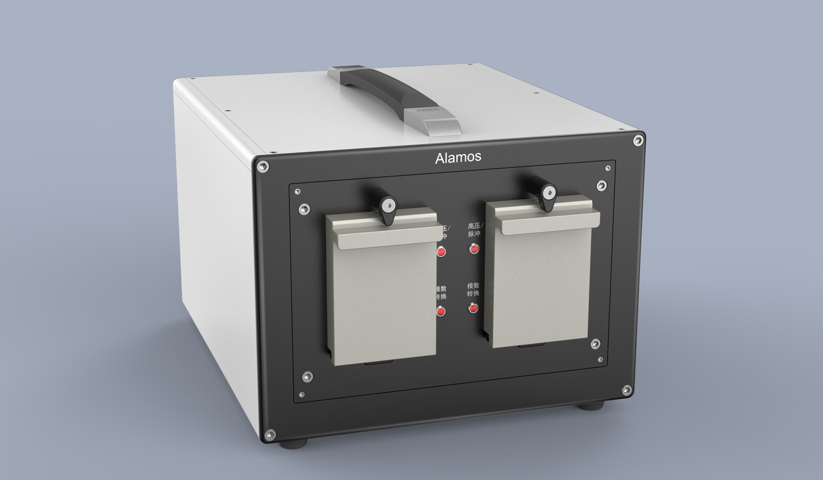

Hardware features
- Two, four, six, and eight routes are available
- detector: interface compatible with domestic and foreign mainstream PIPS detector;
- Measuring area: 300mm2-2000mm2;
- Measuring chamber: inhibit recoil contamination;
- sample tray: the distance is manually adjustable, the adjustment accuracy is 4mm;
- Vacuum control: can be selected for pumping, deflating and holding gas, vacuum real-time display, display range: 0-26kPa;
- Multi-channel: digital multi-channel, 512,1024,2048,4096,8192 channels adjustable by software;
- Bias: 0-180V digital adjustable, adjustment accuracy 0.2V;
- leakage current monitoring: with detector leakage current monitoring function, measuring range: -3~150nA, measuring accuracy: better than 1nA;
- electron peak generator: with the function of electron peak generator, electron peak amplitude is adjustable;
- equipped with virtual oscilloscope function;
- Communication interface: USB, RS232, Ethernet;
Software feature
- both parameter setting and energy spectrum acquisition of spectrometer;
- with energy scale and efficiency scale;
- built-in standard nuclide library, users can choose the user nuclide library;
- built-in α spectrum analysis algorithm;
Spectrometer performance
- Energy range: 3-10MeV;
- Background counting rate: <1 / hour (3-10MeV);
- energy resolution: FWHM≤18keV@5.486MeV (detector 300mm2, detector-source distance equal to detector diameter);
- FWHM≤22keV@5.486MeV (detector 450mm2, detector source distance equal to detector diameter);
- Operating temperature: 0~40℃;
- Humidity: 10%~80%.

